**DAILY ONLINE ACTIVITIES SUMMARY**

|  |  |  |  |  |  |  |  |  |
| --- | --- | --- | --- | --- | --- | --- | --- | --- |
| **Date:** | **24-06-2020** | | | | | **Name:** | **Anix Jugal D’Cunha** | |
| **Sem & Sec** | **8 sem , A sec** | | | | | **USN:** | **4AL16CS013** | |
| **Online Test Summary** | | | | | | | | |
| **Subject** | | **Test was not conducted today** | | | | | | |
| **Max. Marks** | | **--** | | **Score** | | | **--** | |
| **Certification Course Summary** | | | | | | | | |
| **Course** | **Learn Advanced CSS3** | | | | | | | |
| **Certificate Provider** | | | **Udemy** | | **Duration** | | | **1.5 hours** |
| **Coding Challenges** | | | | | | | | |
| **Problem Statement:** Program to Sort a stack using a temporary stack in java. | | | | | | | | |
| **Status: Competed** | | | | | | | | |
| **Uploaded the report in Github** | | | | | **yes** | | | |
| **If yes Repository name** | | | | | **alvas-education-foundation/dcunhaanixjugal** | | | |
| **Uploaded the report in slack** | | | | | **yes** | | | |

Online Test Details: (Attach the snapshot and briefly write the report for the same)

Test was not Conducted Today

Certification Course Details: (Attach the snapshot and briefly write the report for the same)

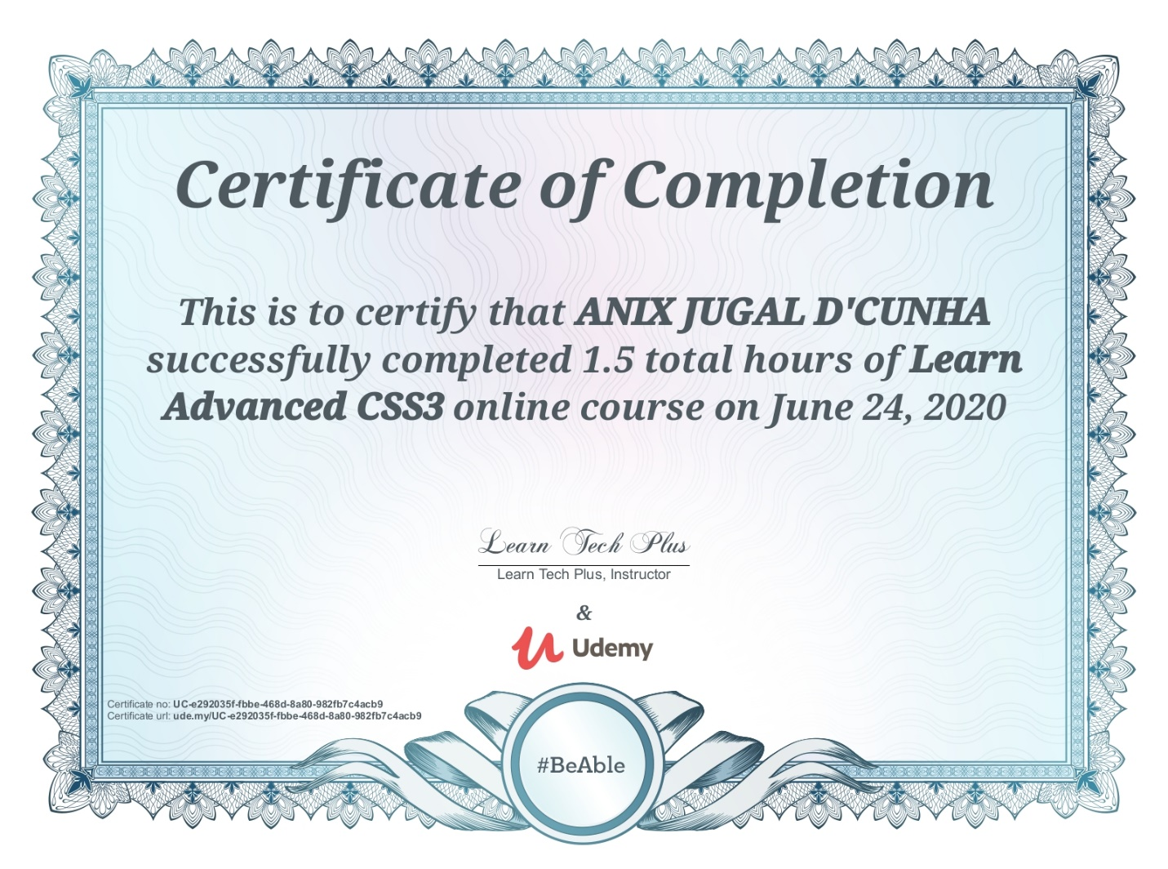

Coding Challenges Details: (Attach the snapshot and briefly write the report for the same)

## Program->  Program to Sort a stack using a temporary stack in java.

|  |
| --- |
|  |
|  |
| Import java.util.*; |
|  |  |
|  | class SortStack |
|  | { |
|  |  |
|  | public static Stack<Integer> sortstack(Stack<Integer> |
|  | input) |
|  | { |
|  | Stack<Integer> tmpStack = new Stack<Integer>(); |
|  | while(!input.isEmpty()) |
|  | { |
|  |  |
|  | int tmp = input.pop(); |
|  |  |
|  | while(!tmpStack.isEmpty() && tmpStack.peek() |
|  | > tmp) |
|  | { |
|  |  |
|  | input.push(tmpStack.pop()); |
|  | } |
|  |  |
|  |  |
|  | tmpStack.push(tmp); |
|  | } |
|  | return tmpStack; |
|  | } |
|  |  |
|  |  |
|  | public static void main(String args[]) |
|  | { |
|  | Stack<Integer> input = new Stack<Integer>(); |
|  | input.add(34); |
|  | input.add(3); |
|  | input.add(31); |
|  | input.add(98); |
|  | input.add(92); |
|  | input.add(23); |
|  |  |
|  | // This is the temporary stack |
|  | Stack<Integer> tmpStack=sortstack(input); |
|  | System.out.println("Sorted numbers are:"); |
|  |  |
|  | while (!tmpStack.empty()) |
|  | { |
|  | System.out.print(tmpStack.pop()+" "); |
|  | } |
|  | } |
|  | } |
|  |  |
|  |  |
|  |  |
|  | Out put: |
|  | Sorted numbers are: |
|  | 3 23 31 34 92 98 |
|  |  |